**Contact information**

Company

Name

Address

Zip Code / Town / Country

Email

Phone

Fax

**Application short description**



**Hexapod Specifications**

**Definition of PI standard coordinate system:**

* Origin is center of plane including all joint centers of uppermost joints
* Z-axis perpendicular to platform
* X-Z-plane is symmetry plane of hexapod base plane

**Motion specifications\***

|  |  |  |  |  |
| --- | --- | --- | --- | --- |
| **Degree of freedom²** | **Displacement** | **Repeatability³** | **Resolution4** | **Pivot Point**  **=**  **Center of rotation5** |
| **X** | ± mm | ± µm | ± µm |
| **Y** | ± mm | ± µm | ± µm |
| **Z** | ± mm | ± µm | ± µm |
| **Theta X (U)** | ± ° | ± ° | ± ° | **X (R)** = ……… mm |
| **Theta Y (V)** | ± ° | ± ° | ± ° | **Y (S)** = ……… mm |
| **Theta Z (W)** | ± ° | ± ° | ± ° | **Z (T)** = ……… mm |

*\* According to shown hexapod coordinate system if not other specified in sketch on next page.*

*² Please state: □ All specifications are single axis motions. □ All specifications are combined motions.*

*³ PI typically defines uni-directional repeatability. Please state: uni-directional □ or bi-directional □*

*4 PI defines resolution as minimum incremental motion / minimum step size.*

*5 From the top and center of hexapod platform*

**Testing requirements:**

…………………………………………………………………………………………………………………….

|  |
| --- |
|  |

**Set-up of application (mounting, cabling, …):**

Please enter your axis orientation according to the travel requirements given above

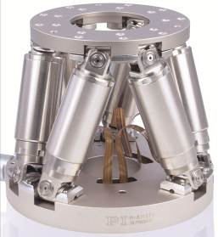**Payload**

Mass kg

Horizontal ………………………………… mm

Vertical mm

**Center of gravity** (cog / from the top and center of hexapod platform)

X mm

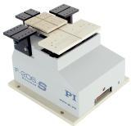Y mm

Z mm

**Mass Moment of Inertia** (relative to cog of payload)

Ixx (roll) kgm²

Iyy (pitch) kgm²

Izz (yaw) kgm²

**Further requirements (size, weight, available installation space, …)** ………………………

**Interfaces (mechanical, electrical, software, …)**

**Environmental conditions (temperature, humidity, vacuum, clean room, dust, …)**

**Commercial aspects (price target, delivery time frame):**

**Notes:**

……………………………………………………………………………………………………………………….